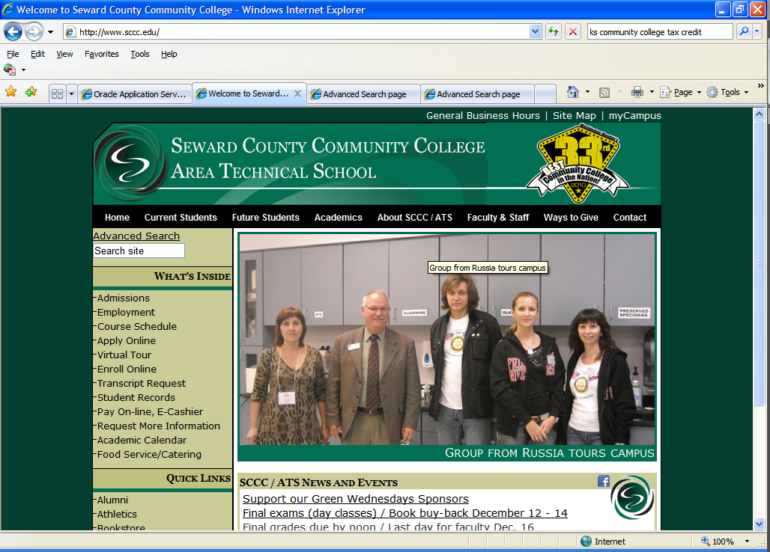
Click on myCampus

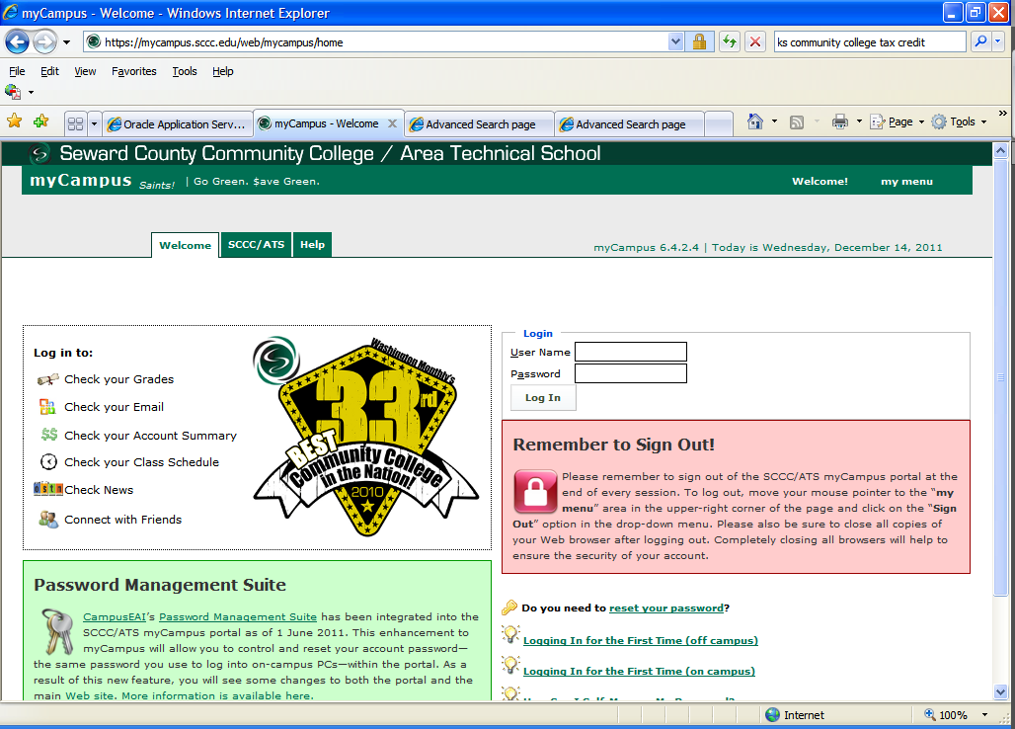
Type in User Name. Example: john.doe
Next type in your current Password for electronic services.
Never logged in before? See information under the pink box.

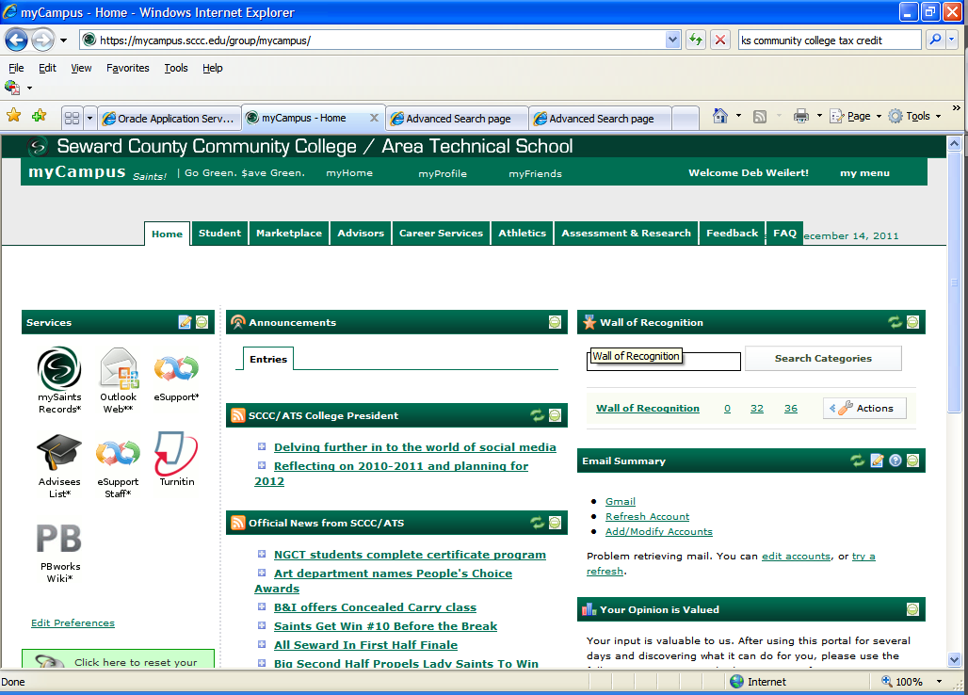

Click on mySaints icon

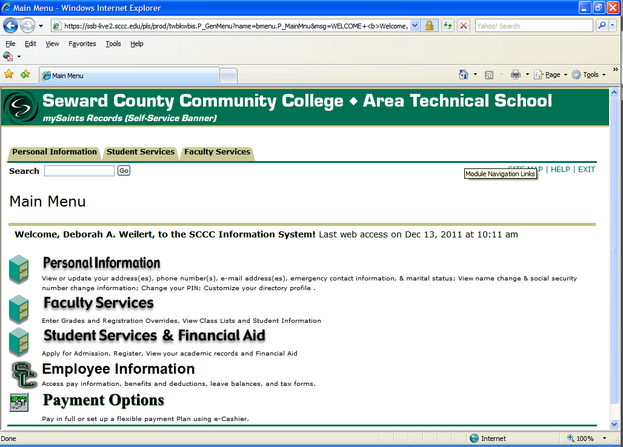

Click on Employee Information

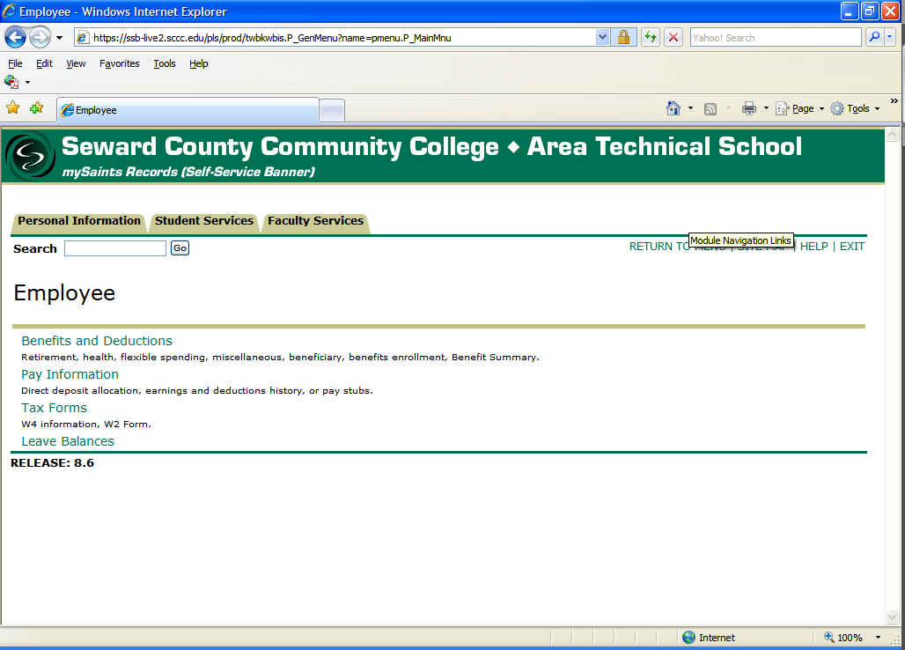
Click on information you wish to view, such as Leave Balances.
Break out of each option is below

Benefits and Deductions
Retirement, health, flexible spending, miscellaneous, beneficiary, benefits enrollment, benefit summary

Retirement Plans:
KPERS
TIAA-CREF employer
TIAA-CREF employee
TIAA-CREF supplemental employee

History shows all changes in Banner since August 1999
Retirement Contributions or Deductions shows current year
From and to dates may be changed to view different months/years

Health Benefits:
BCBS Dental (pre- and after-tax)
BCBS Health (pre- and after-tax)

History shows all changes in Banner since August 1999
Retirement Contributions or Deductions shows current year
From and to dates may be changed to view different months/years
Vendor Web Site will take you to www.bcbsks.com

Flex Benefits:
Currently not showing on the system will show Section 125, pre-tax deductions such as Aflac pre-tax supplemental insurance premiums.

Flexible Spending Accounts:
Flexible Medical Reimbursement
Flexible Dependent Day Care

History shows all changes in Banner since August 1999
Details n/a
Retirement Contributions or Deductions shows current year
From and to dates may be changed to view different months/years
Vendor Web Site will take you to http://aflaconlineservices.com

Miscellaneous (Employee Voluntary Deductions/Contributions, Judicial Deductions and Employer Paid Benefits)
Aflac Group After-Tax
Aflac Core After-Tax
Booster Club
Child Support
Development Foundation Contributions
Garnishment
Liquidated Damages
Miscellaneous (Special deductions set-up by the employee)
PEA
Reserve Seating
Short Term Disability Ins (Employer paid benefit for the employee)
Student Loan Default
Work Comp (Employer paid)
United Way

History shows all changes in Banner since August 1999
Retirement Contributions or Deductions shows current year
From and to dates may be changed to view different months/years

Beneficiaries and Dependents
Currently testing

Benefit Summary
Personal Data:
Department
Benefit Category
Date of Birth
Original Hire Date
Current Hire Date
Adjusted Service Date (Full-time employees/eligible for benefits)

Pay Information
Direct deposit allocation, earnings and deductions history, pay stubs

Direct Deposit Allocation (shows current accounts and distributions)
Update Direct Deposit Allocation

Select a bank name to change an existing record, or select different priorities and the reorder button to change the order of existing records. Enter the bank routing number and account information to add a direct deposit, then choose Save.
IMPORTANT: If you want your paycheck deposited into more than one account, the account your want your remaining amount going into must be set as the last Priority.
Example: You want $100 deposited into account A, $50 into account B with the remaining amount deposited into account C. Account A & B will be Priority 1 & 2 with account C set at Priority 3.

Enter: Bank Routing Number
Account Number
Account Type (Savings or Checking)
Check remaining amount if applicable
Amount or Percent

Click on “Save”

Earnings History
Criteria/Choose a date range and then select “Display”

Pay Stub
Choose a year then select “Display”
Pay Stub Date
Pay Period Begin Date
Pay Period End Date
Gross Pay
Net Pay

Deductions History
Choose the From and To date range then select “Display”
Deduction Type
Employee Deduction Amount
Employer Deduction Amount

Earnings by Position
Selection will be removed from future viewing

Tax Forms
W4 information, W2 form

W-4 Employee’s Withholding Allowance Certificate
Shows current Federal Tax Withholding Allowance Certificate, may be printed

History shows all changes in Banner since August 1999
Update allows employee to change federal withholding allowances and additional withholding. Change requires certification by re-entering “User Password.” Change is immediate.
W4 Contributions or Deductions shows current year
From and to dates may be changed to view different months/years
Vender web site takes employee to current year fill-in form, which may be completed, printed, and submitted to the HR Office

Electronic W-2 Consent
Employee consents to receive W2 electronically, or uncheck to revoke consent

W-2 Wage and Tax Statement
Select Tax Year and then select “Display”
After selecting display W2 statement will display
W2s from 2006 forward may be printed by selecting “Print” at the bottom of the screen

Leave Balances

Leave Balances
Shows most current balance after the processing of current payroll. See information below

Salary Personnel: Balances as of the 1st day of the month you received your last paycheck. Salary Personnel Example: Your last paycheck was September 22nd, then your leave balances are as of September 1st.
Hourly Personnel: Balances as of the 11th day of the month you received your last paycheck. Hourly Personnel Example: Your last paycheck was September 22nd, then your leave balances are as of September 11th.
Note: A few employees fall under a grandfather in clause. These employees will follow the Salary Personnel example above.
How much leave do I need to use prior to July 1? Available Beginning Balance minus Taken.

